Practice 3 Comprehensive Report: Statistical Analysis of Hormone Variables in data_for_analysis
Introduction
Statistical analysis plays an important role in understanding the structure, variability, and relationships within biomedical data. In this practical task, the focus is on comparing hormone-related variables between two independent groups defined by the outcome variable in the dataset data_for_analysis.
The assignment required a structured workflow that combines descriptive statistics, normality assessment, variance testing, graphical distribution analysis, group comparison tests, and correlation analysis. This sequence is important because the choice of statistical method depends on the distributional properties of the data and the assumptions checked in earlier stages of the analysis.
This report presents a comprehensive account of the full analysis from Question 1 to Question 5, arranging the code, results, and interpretation in the same flow so that each stage is clearly linked to its output and meaning.
Aim
The aim of this report is to analyze the hormone variables in the data_for_analysis dataset by comparing their descriptive characteristics, distributional behavior, group differences, and correlation structure across the two outcome groups.
Objectives
- To generate descriptive statistics for all hormone variables by outcome group.
- To assess normality using the Shapiro-Wilk test for each hormone variable in each group.
- To assess homogeneity of variance using Levene’s test.
- To visualize the distribution of hormone variables using histograms and Q-Q plots.
- To compare the two outcome groups using Brunner-Munzel, Student’s t-test, and Wilcoxon rank-sum test.
- To construct separate correlation heatmaps for the two groups and interpret the observed patterns.
Data description
The assignment identifies the working dataset as data_for_analysis, stored as a CSV file with 1148 observations and 31 variables. The attached CSV includes record_id, outcome, several factor variables, hormone variables, lipid variables, oxidative variables, and antioxidant variables.
For this task, the variables selected for analysis were the hormone-related variables hormone1, hormone2, hormone3, hormone4, hormone5, hormone6, hormone7, hormone8, and hormone10_generated. The grouping variable was outcome, which was treated as a factor so that all analyses could be carried out separately for the two independent groups coded as 0 and 1.
Question 1: Descriptive statistics by group
The first requirement of the task was to create a table with descriptive statistics for all hormone variables by outcome group.
Code
install.packages("dplyr")
install.packages("gtsummary")

library(dplyr)
library(gtsummary)

# Read data
data_for_analysis <- read.csv("data_for_analysis-1.csv")

# Make outcome a factor
data_for_analysis$outcome <- factor(data_for_analysis$outcome)

# Hormone variables required for Task 3
hormone_vars <- c(
"hormone1", "hormone2", "hormone3", "hormone4",
"hormone5", "hormone6", "hormone7", "hormone8",
"hormone10_generated"
)

# Descriptive statistics table by outcome
desc_table <- data_for_analysis %>%
select(outcome, all_of(hormone_vars)) %>%
tbl_summary(
by = outcome,
statistic = list(
all_continuous() ~ "{mean} ({sd}); {median} [{p25}, {p75}]; n={N_nonmiss}; miss={N_miss}"
),
digits = all_continuous() ~ 2
)

desc_table
Result
The grouped descriptive table was produced successfully and displayed all selected hormone variables by outcome group. The table showed N = 987 for outcome 0 and N = 160 for outcome 1, which is consistent with the group sizes reflected in the assignment example. See Fig 1
Each table cell contained the mean, standard deviation, median, first quartile, third quartile, number of non-missing values, and number of missing values for the corresponding hormone variable. This made the table suitable as a descriptive summary for later integration with the inferential test results
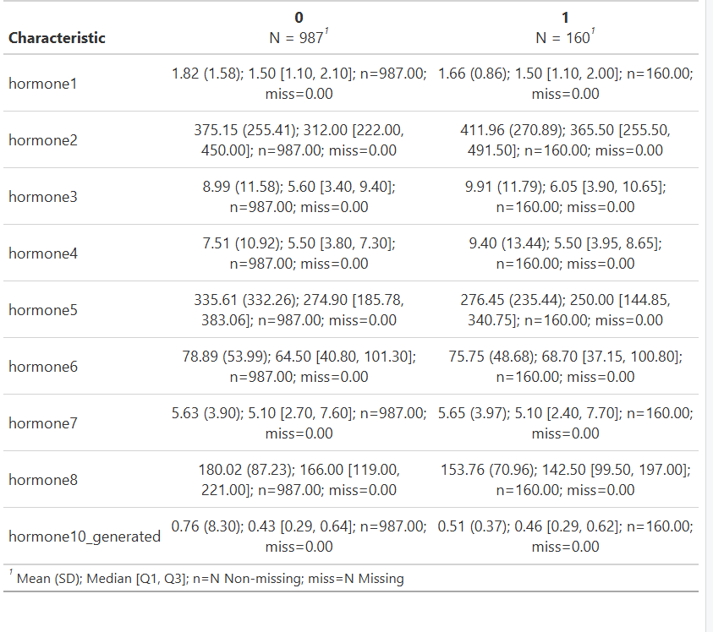Figure 1: Descriptive statistics table by outcome group for all hormone variables in the dataset.

Interpretation
The descriptive statistics suggested that several hormone variables were not symmetrically distributed because the means and medians differed noticeably for some variables. In particular, the distribution summaries indicated the possible presence of right-skewness and extreme values, which justified proceeding to formal normality testing in Question 2
Question 2: Shapiro-Wilk and Levene’s tests
The second requirement of the task was to perform the Shapiro-Wilk test for normality and Levene’s test for homogeneity of variance for all hormone variables.
Code
install.packages("car")
install.packages("dplyr")

library(dplyr)
library(car)

# Read data
data_for_analysis <- read.csv("data_for_analysis-1.csv")
data_for_analysis$outcome <- factor(data_for_analysis$outcome)

# Hormone variables
hormone_vars <- c(
"hormone1", "hormone2", "hormone3", "hormone4",
"hormone5", "hormone6", "hormone7", "hormone8",
"hormone10_generated"
)

# Store results
test_results <- lapply(hormone_vars, function(var) {

values_0 <- na.omit(data_for_analysis[data_for_analysis$outcome == 0, var])
values_1 <- na.omit(data_for_analysis[data_for_analysis$outcome == 1, var])

shapiro_0 <- shapiro.test(values_0)
shapiro_1 <- shapiro.test(values_1)

levene_res <- leveneTest(as.formula(paste(var, "~ outcome")), data = data_for_analysis)

data.frame(
Variable = var,
Shapiro_p_outcome0 = shapiro_0$p.value,
Shapiro_p_outcome1 = shapiro_1$p.value,
Levene_p = levene_res$`Pr(>F)`[1]
)
})

test_results_df <- bind_rows(test_results)
test_results_df
Result
The test output table was generated successfully with one row per hormone variable and three p-value columns: Shapiro_p_outcome0, Shapiro_p_outcome1, and Levene_p. The Shapiro-Wilk p-values for all hormone variables in both groups were extremely small and below 0.05. For example, hormone1, hormone2, hormone5, and hormone10_generated all had p-values that were effectively near zero in both groups.
The Levene’s test p-values were mostly above 0.05, with examples including approximately 0.0868 for hormone1, 0.9787 for hormone2, 0.1653 for hormone5, and 0.6909 for hormone10_generated. This suggests that strong variance inequality was not consistently demonstrated across the hormone variables.
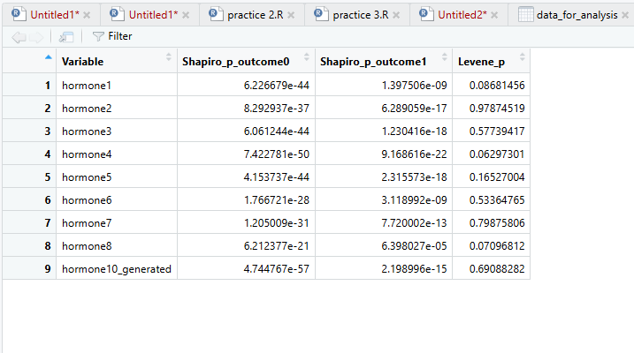 Figure 2: Shapiro-Wilk normality test and Levene’s homogeneity of variance test results
Interpretation
The Shapiro-Wilk results indicate that normality should be rejected for all hormone variables in both outcome groups. This is an important finding because it means the normality assumption required for the ordinary Student’s t-test is not satisfied.
The Levene’s test results suggest that unequal variances were not the main issue for most variables in the displayed output. However, non-normality alone is already sufficient to justify caution when selecting parametric procedures, so later analyses should prioritize non-parametric or more robust alternatives.
Question 3: Histograms and Q-Q plots
The third requirement of the task was to generate histograms and Q-Q plots for all hormone variables.
Code
data_for_analysis <- read.csv("data_for_analysis-1.csv")
data_for_analysis$outcome <- factor(data_for_analysis$outcome)

hormone_vars <- c(
"hormone1", "hormone2", "hormone3", "hormone4",
"hormone5", "hormone6", "hormone7", "hormone8",
"hormone10_generated"
)

for (var in hormone_vars) {

values_0 <- na.omit(data_for_analysis[data_for_analysis$outcome == 0, var])
values_1 <- na.omit(data_for_analysis[data_for_analysis$outcome == 1, var])

par(mfrow = c(2, 2))

hist(values_0, main = paste("Histogram:", var, "(outcome 0)"),
col = "lightblue", xlab = var)
qqnorm(values_0, main = paste("Q-Q Plot:", var, "(outcome 0)"))
qqline(values_0, col = "red", lwd = 2)

hist(values_1, main = paste("Histogram:", var, "(outcome 1)"),
col = "lightgreen", xlab = var)
qqnorm(values_1, main = paste("Q-Q Plot:", var, "(outcome 1)"))
qqline(values_1, col = "red", lwd = 2)

readline(prompt = paste("Press [Enter] to see plots for", var))
}
Result
The plots were generated successfully in a 2-by-2 layout for each hormone variable, with histograms and Q-Q plots shown separately for outcome 0 and outcome 1. For hormone1, the histogram in outcome 0 showed a strong right-skewed distribution and the Q-Q plot showed a large departure from the normal reference line, especially in the upper tail.
For hormone10_generated, the outcome 0 histogram showed an extreme concentration of values near the lower range together with a very large upper outlier, and its Q-Q plot displayed severe deviation from the reference line. In the outcome 1 group, the variable still appeared right-skewed, although less extreme than in outcome 0.
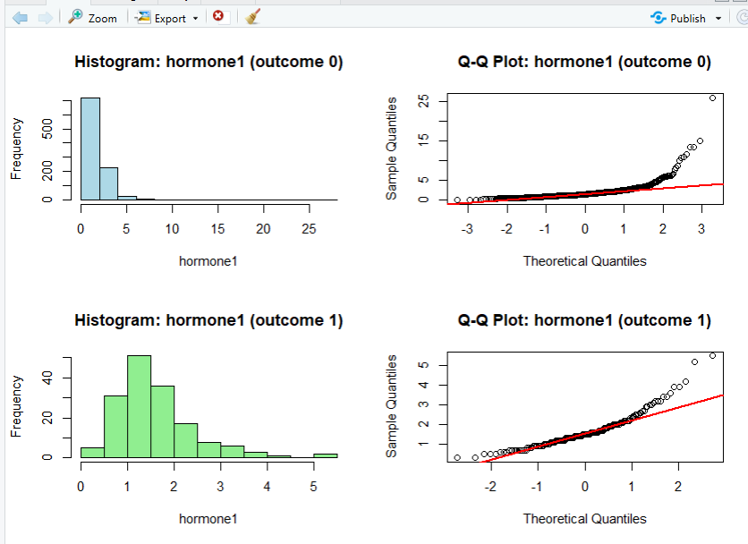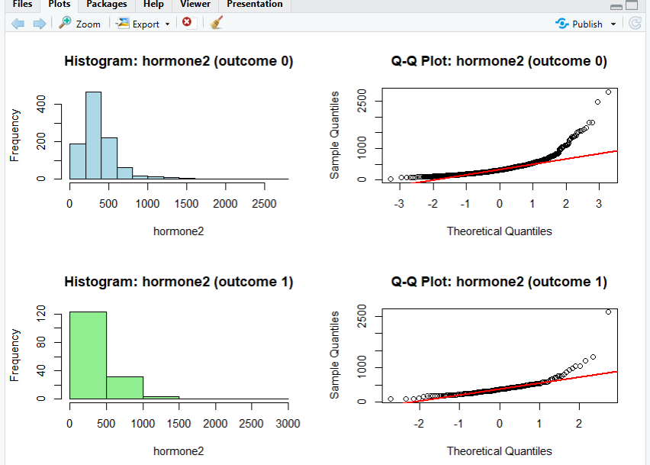
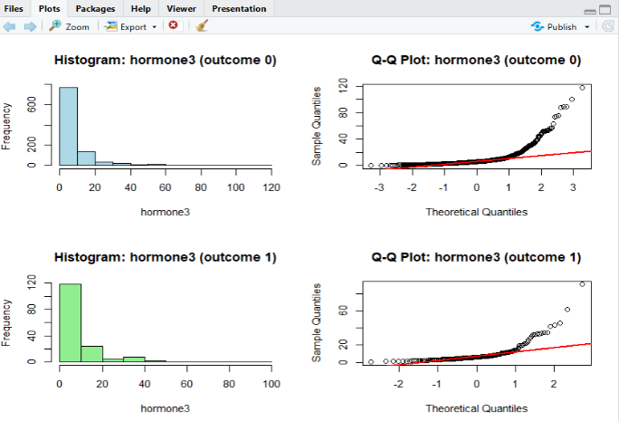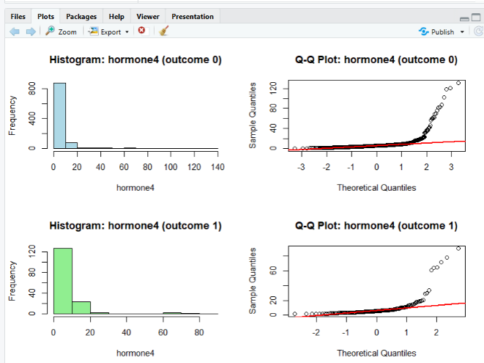
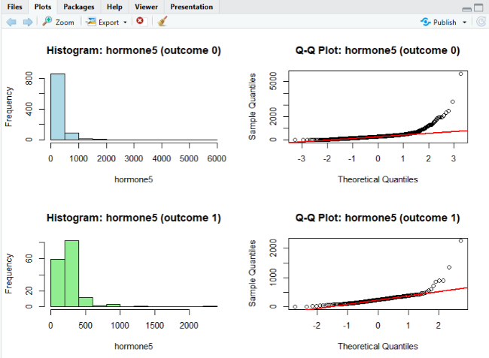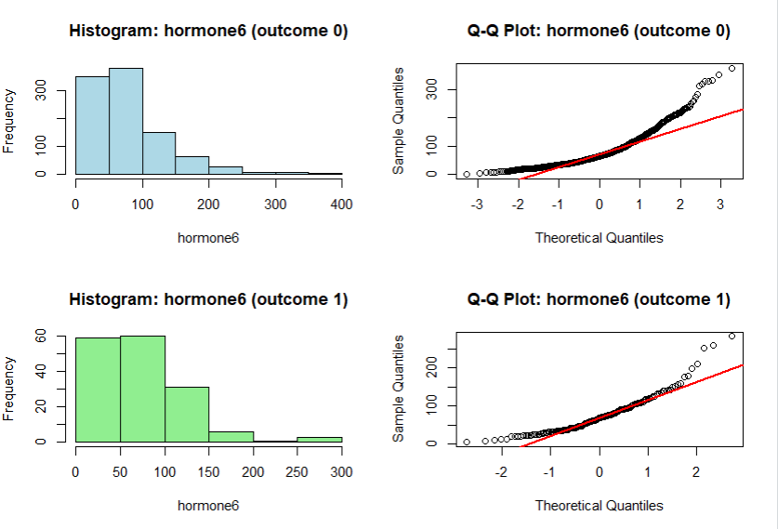
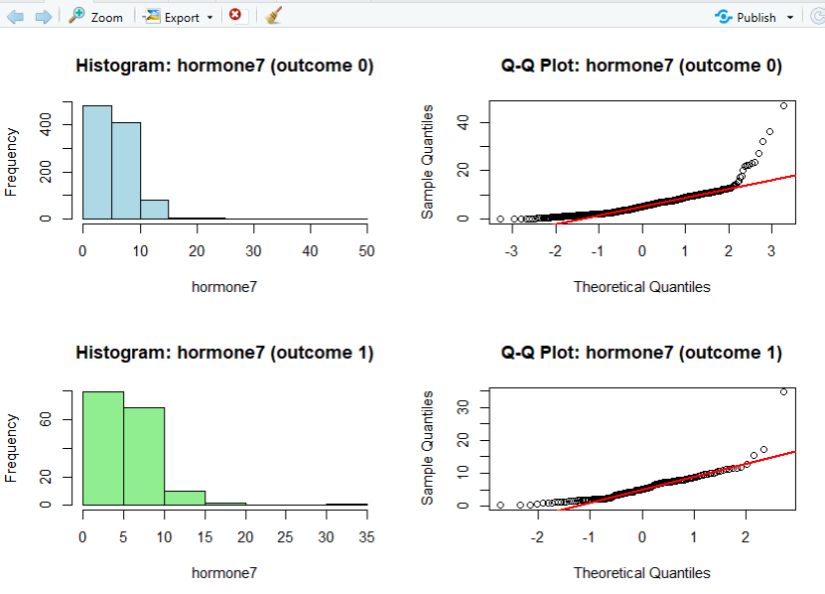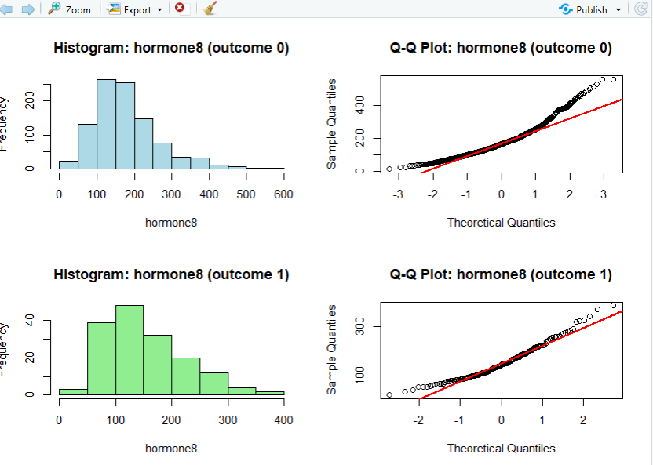
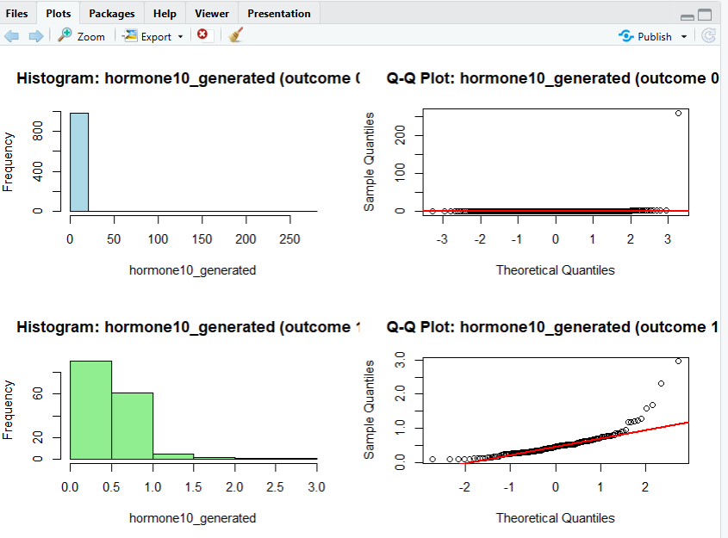Figure 3: Histograms and Q-Q plots of hormone variables (hormone1 to hormone8 and hormone10_generated) for outcome groups 0 and 1, showing the distributional patterns and departures from normality across the two groups.

Interpretation
The histograms and Q-Q plots demonstrate that the hormone variables are not normally distributed in either outcome group. Most histograms show a concentration of values at the lower end with long right tails, while the Q-Q plots display substantial deviation from the reference line, particularly in the upper quantiles, indicating positive skewness and the presence of extreme observations. Although both outcome groups show clear departures from normality, the degree of skewness and spread differs across some variables, with outcome 0 often showing greater dispersion or more extreme upper-tail values than outcome 1. These findings confirm the Shapiro-Wilk results and indicate that the assumption of normality is violated in both groups. Therefore, the graphical analysis supports the use of non-parametric or robust methods for the subsequent group comparisons.

Question 4: Brunner-Munzel, t-test, and Wilcoxon comparison
The fourth requirement of the task was to perform Brunner-Munzel, Student’s t-test, and Wilcoxon rank-sum test for the two independent groups for all hormone variables, then identify which test is applicable.
Code
install.packages("lawstat")
install.packages("dplyr")

library(lawstat)
library(dplyr)

data_for_analysis <- read.csv("data_for_analysis-1.csv")
data_for_analysis$outcome <- factor(data_for_analysis$outcome)

hormone_vars <- c(
"hormone1", "hormone2", "hormone3", "hormone4",
"hormone5", "hormone6", "hormone7", "hormone8",
"hormone10_generated"
)

test_compare <- lapply(hormone_vars, function(var) {

group0 <- na.omit(data_for_analysis[data_for_analysis$outcome == 0, var])
group1 <- na.omit(data_for_analysis[data_for_analysis$outcome == 1, var])

bm <- brunner.munzel.test(group0, group1)
tt <- t.test(group0, group1)
wx <- wilcox.test(group0, group1)

data.frame(
Variable = var,
Brunner_Munzel_p = bm$p.value,
t_test_p = tt$p.value,
Wilcox_p = wx$p.value
)
})

test_compare_df <- bind_rows(test_compare)
test_compare_df
Result
The output table for Question 4 was produced correctly with one row per hormone variable and three p-value columns corresponding to the required tests. Using a 0.05 significance threshold, the results indicate statistically significant group differences for hormone2, hormone5, and hormone8 across all three tests.
For example, hormone2 had Brunner-Munzel p = 0.00359, t-test p = 0.10960 and Wilcoxon p = 0.00540 shown in the screenshot, while hormone5 and hormone8 also had small p-values indicating group differences. Most of the other hormone variables had p-values above 0.05 in the displayed output.
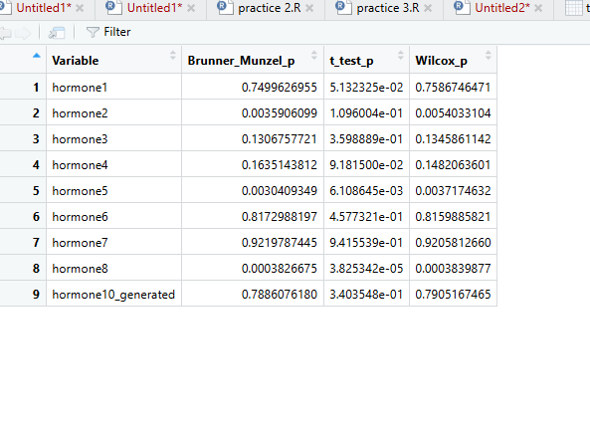 Figure 4: Comparison of Brunner-Munzel, Student’s t-test, and Wilcoxon rank-sum test p-values for hormone variables across the two outcome groups.
Interpretation
Because Question 2 showed that all hormone variables were non-normal in both groups, the ordinary Student’s t-test is not the most appropriate primary inference method for this dataset. The assignment notes that Wilcoxon is suitable for non-normal data and that Brunner-Munzel is especially useful when data are non-normal and variance assumptions may be uncertain.
For this reason, the most appropriate main test for the present analysis is the Brunner-Munzel test, with the Wilcoxon rank-sum test also serving as a reasonable non-parametric comparison. The t-test can be reported for completeness, but it should not be treated as the main basis for inference because its normality assumption was not met.

Question 5: Correlation heatmaps by group
The fifth requirement of the task was to construct separate correlation heatmaps for all hormones in each outcome group and to select Pearson or Spearman correlation according to normality.
Code
install.packages("corrplot")

library(corrplot)

# Read data
data_for_analysis <- read.csv("data_for_analysis-1.csv")
data_for_analysis$outcome <- factor(data_for_analysis$outcome)

# Hormone variables
hormone_vars <- c(
"hormone1", "hormone2", "hormone3", "hormone4",
"hormone5", "hormone6", "hormone7", "hormone8",
"hormone10_generated"
)

# Subset groups
group0_data <- data_for_analysis[data_for_analysis$outcome == 0, hormone_vars]
group1_data <- data_for_analysis[data_for_analysis$outcome == 1, hormone_vars]

# Compute Spearman correlations
cor_group0 <- cor(group0_data, method = "spearman", use = "pairwise.complete.obs")
cor_group1 <- cor(group1_data, method = "spearman", use = "pairwise.complete.obs")

# Plot heatmaps
par(mfrow = c(1, 2))

corrplot(cor_group0,
method = "color",
type = "upper",
tl.col = "black",
tl.srt = 45,
title = "Outcome 0: Spearman Correlation",
mar = c(0, 0, 2, 0))

corrplot(cor_group1,
method = "color",
type = "upper",
tl.col = "black",
tl.srt = 45,
title = "Outcome 1: Spearman Correlation",
mar = c(0, 0, 2, 0))
Result
The final heatmaps were produced successfully as two side-by-side Spearman correlation matrices, one for outcome 0 and one for outcome 1. This satisfies the requirement to construct separate correlation heatmaps for the two groups and to choose the correlation method based on data normality.
The heatmaps showed that most hormone pair relationships were weak to moderate, as indicated by the relatively light color intensity in many cells. Some blue cells indicated positive associations, while a few orange-toned cells indicated negative associations.
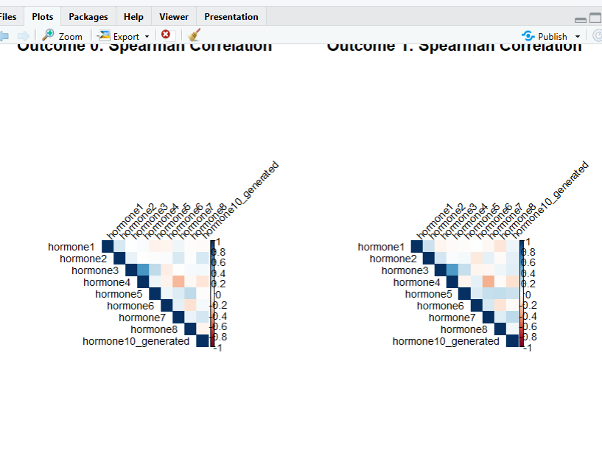 Figure 5: Spearman correlation heatmaps for hormone variables in outcome groups 0 and 1.
Interpretation
Spearman correlation was the correct choice because the Shapiro-Wilk results showed non-normal distributions across all hormone variables. The correlation heatmaps suggest that the association structure among the hormone variables differs somewhat between outcome 0 and outcome 1, because the pattern and intensity of colored cells are not identical across the two matrices.
This indicates that hormone interactions may vary according to outcome status. Although most associations appear weak to moderate, the visual differences between the two groups provide useful evidence that the dependence structure among hormones is not uniform across the groups.
Conclusion
This report presented a complete statistical analysis of the hormone variables in the data_for_analysis dataset across the two outcome groups. The workflow included descriptive statistics, normality assessment, variance testing, histograms, Q-Q plots, three comparative tests, and correlation heatmaps.
The main findings are that the hormone variables were non-normal in both groups, the variance assumption was not the primary concern for most variables, Brunner-Munzel was the most appropriate primary group comparison test, and correlation patterns differed between the outcome groups. In the displayed results, hormone2, hormone5, and hormone8 showed the clearest evidence of significant differences between the two groups.

References
- Blanca, M. J., Alarcón, R., Arnau, J., Bono, R., & Bendayan, R. (2017). Non-normal data: Is ANOVA still a valid option? Psicothema, 29(4), 552–557.
- Conover, W. J., Johnson, M. E., & Johnson, M. M. (1981). A comparative study of tests for homogeneity of variances, with applications to the outer continental shelf bidding data. Technometrics, 23(4), 351–361.
- Ghasemi, A., & Zahediasl, S. (2012). Normality tests for statistical analysis: A guide for non-statisticians. International Journal of Endocrinology and Metabolism, 10(2), 486–489.
- Mishra, P., Pandey, C. M., Singh, U., Gupta, A., Sahu, C., & Keshri, A. (2019). Descriptive statistics and normality tests for statistical data. Annals of Cardiac Anaesthesia, 22(1), 67–72.
- Neuhäuser, M., & Ruxton, G. D. (2020). Nonparametric statistical methods in medical research. Anesthesia and Analgesia, 131(6), 1862–1880.

